Parkland School

Charter

2023

41 Parkland Crescent
Palmerston North

School ID Number - 2424

Parkland School - Visual Charter

Parkland School – Our Vision

Rise to the Challenge - Whāia te iti Kahurangi

Every child will….’Rise to the Challenge’
Parkland students will face daily challenges based on identified, evidence based learning needs. A variety of challenges will also include sporting/physical, cultural and social needs. A key focus for individual challenges in the next three years will be grounded in the Parkland Key Competencies, which sit alongside our core school values.
Students will be explicitly taught, develop and understand strategies and skills that can be used to overcome the challenges they might face.
Students will have an understanding of the challenges they face and what their next steps are in order to achieve those challenges.
A strong component of our vision will be the learning partnerships we value and deliberately promote.

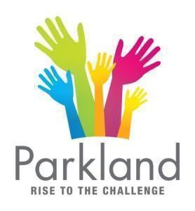
Parkland School – Values
We have a set of ‘living values’ that are visible throughout the school and in the behaviours and standards our students are expected to exhibit. Children will know what we mean by each of the values at their level and will be able to provide examples of the things we do in our classrooms, playground and daily lives to demonstrate each of the values.
CONSIDERATION – For Ourselves
CONSIDERATION - For Others
CONSIDERATION - For the Environment
RESPECT
HONESTY
EXCELLENCE

Parkland School LOGO

Rise to the Challenge
Whāia te iti kahurangi
‘R

The combination of the hands reaching upwards is a clear link to our active vision statement of ‘Rising to the Challenge’.
The different sized hands represent the varied learning partnerships we encourage throughout the school. Children, teachers, parents and the school community working together and supporting each other.

Parkland School Key Competencies

Year 1 & 2
‘I’m just learning’ | ‘I’m almost there’ | ‘I’m a Pro’

At Parkland School we are developing students who are….
Thinkers | Communicators | Self Managers | Contributors
We are active problem solvers.  We are curious about the world around us.  We are creative thinkers.  We are able to use feedback positively.  We use prior knowledge to help our thinking.  We are aware of our own thinking, feelings & actions and are aware of the effect on others. | We are active listeners and can ask questions to gain deeper understanding.  We respect different points of view and share ideas with consideration and understanding.  We are confident speakers.  We are able to communicate using a range of methods to suit the audience. | We are responsible for our own property.  We are willing to take risks in our learning.  We can clearly explain our learning & know our next steps.  We follow instructions & routines.  We have a positive attitude.  We believe in ourselves.  We persevere.  We are organised and ready for learning. | We are helpful and show initiative.  We interact positively and respect differences.  We actively participate and contribute positively to the school community.  We identify and accept different roles in different situations.

Year 3 – 6
Recruit | Intern | Skilled | Expert

At Parkland School we are developing students who are….
Thinkers | Communicators | Self Managers | Contributors | Collaborators
We are curious about the world around us.  We question and challenge old and new information.  We are creative, flexible and innovative thinkers.  We draw on prior knowledge to help our thinking.  We communicate our thinking clearly.  We are aware of our own thinking, feelings and actions and their effect on others. | We are active listeners & can ask questions to gain deeper understanding.  We respect different points of view and share ideas with consideration and understanding.  We are confident speakers.  We are confident writers. | We have a positive learning attitude.  We are resilient.  We are organised and ready for learning.  We are accountable and accepting of responsibility.  We are responsible and respectful of our own and others' property.  We demonstrate perseverance.  We are willing to take acceptable risks.  We can clearly explain what we are learning and why.  We know our next steps in learning.  We have self belief and set high standards. | We are helpful and show initiative.  We respect diversity & interact positively with others.  We have a positive impact on others.  We are actively involved & contribute positively to the school community. | We are diplomatic, encouraging and accepting of others' ideas in a group.  We work collaboratively with others in a group towards a common goal.  We are willing to share our own ideas in a group, so we can collaborate to develop them.  We listen respectfully & actively to the contributions of others so we can fully understand and participate

Local Curriculum – Rangitane Iwi
Parkland School acknowledges New Zealand’s cultural diversity and the unique position of Maori culture.
- We recognise and value the importance of the teacher-learner relationship
- We believe Maori students should achieve educational success as Maori
- Teachers will know their students' backgrounds (identity), capabilities and will foster positive and productive relationships between students, Whanau and the school.
- The school acknowledges and respects the importance of the cultural competencies for teachers. (Tataiako) Professional development will be provided to enable staff to explore and gain greater understanding of these.
- We will take all reasonable steps to include Tikanga Maori and Te Reo Maori within school programmes.
- We will foster the positive relationships already established between families, Whanau and the school through regular and direct personal contact, based around the learning and cultural needs of students.
- The school will recognise, consider and be inclusive of students with Pacific backgrounds.

The board will respond to any request for instruction in Te Reo Maori by:
- Advising the parent of the current level of Te Reo and Tikanga Maori available at the school
- Offering to explore possibilities for extending the current provision including:
- Dual enrolment with The Correspondence School
- Consulting with the School Adviser Maori
- Consulting with another school able to provide a higher level of Te Reo and Tikanga Maori

Rangitane Iwi Partnership & Local Inclusive Curriculum
Parkland School and the Board of Trustees
- firstly acknowledge the special status of Maori as Tangata Whenua of Aotearoa New Zealand.
- Secondly Te Reo Maori, Maori Language 1987 as an Official Language of Aotearoa New Zealand and
- Thirdly Te Tiriti o Waitangi the Treaty of Waitangi 1840 as the founding document of Aotearoa New Zealand as a Nation.

Parkland School is located in the North-Eastern corner of Palmerston North City and therefore amongst the Mana-Whenua Iwi, Rangitane O Manawatu.
On the 17th February 2016 Parkland School signed a Memorandum of Understanding (MOU) direct with Tanenuiarangi Manawatu Incorporated on behalf of Rangitane O Manawatu Iwi.
The key objective of the MOU is to enable Rangitane O Manawatu Iwi and Parkland School to establish a collaborative mutually respectful relationship that further enhances the schools determination to support the education pathways of all learners and their whanau and the wider Parkland School community.
This support is encased within the Cultural Responsive Framework (He Tohu Aroha) collaboratively developed with Rangitane O Manawatu Iwi as part of our Teacher Led Innovation Fund project. (TLIF)
Our focus:
- To develop effective teacher practice
- To grow teacher knowledge of culturally responsive practice
- To grow teacher knowledge of Rangitane tikanga, kawa & history
- To enhance student hauora and identity
- To develop and maintain positive, respectful relationships with Rangitane iwi

Rangitane Logo…
"Our Logo speaks of a dynamic and purposeful movement forward for Rangitāne in the Manawatū.
The Gold Koru denotes the Wairua, Life and the Unity of the Tangata Whenua,
The Green Koru reflects the living natural forces,
The Black Koru the strong background of ancestral heritage,
The Red Feather represents our Tinorangatiratanga, by working through the power of the pen we will regain and holdfast to our resources.

Parkland School Strategic Priorities

2020 - 2023

Traditional values within a culture of consideration.

Student Achievement | Kahui Ako | Parkland Key Competencies | Active, Healthy, Balanced Lives | Partnerships | Future Focussed
Broad Goal | Broad Goal | Broad Goal | Broad Goal | Broad Goal | Broad Goal
All students will achieve at or beyond national expectations at their level. | The Kahui Ako will strengthen our collective and collaborative practice by prioritising and focussing on clearly identified needs. | Students will ‘grow’ through each of the developmental stages for each of the respective Parkland Key Competencies.  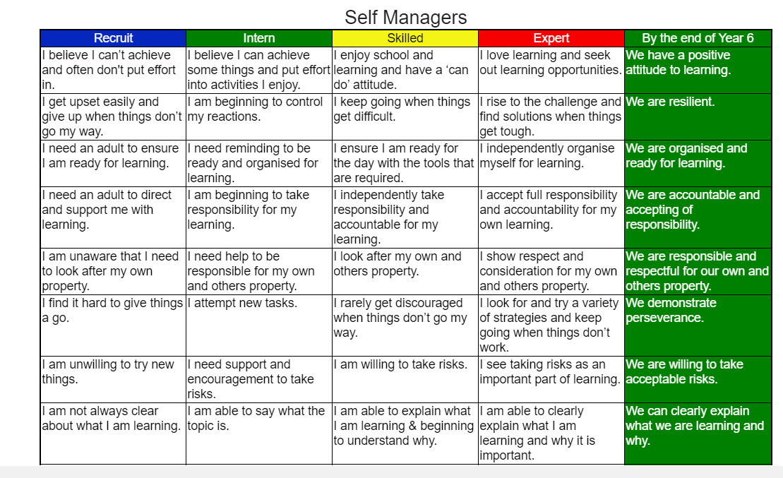 | Students will have active, healthy and balanced lives. | Students achievements and well being/hauora will be enhanced by a range of positive and supportive learning partnerships. | We will support learners to recognise that they have a stake in the future, and a role and responsibility as citizens to take action to help shape that future.

Strategic Plan 2023 - 2025

2023 | 2024 | 2025
 | New Principal Appointed
Review -  Key areas of Charter.  Confirm direction.  Focus on school values and Key Competencies. | Development of strategic documents to meet new requirements.  Curriculum Development
Mathematics  Year 3 of Maths development with Kirsty Sylvester | Review of Mathematics achievement over past three years.
Literacy Development  Year 1  Introduction of Structured Literacy with Liz Kane  Linked to Teacher Inquiry / AOV | Literacy Development  Year 2  Focus to be determined | Literacy Development  Year 3  Focus to be determined
Te Tiriti o Waitangi  Cultural Competency to Responsive Pedagogy  Year 2  Complete Akonga Programme.  Rangitane Symposium  Rongohia Te Hau - Undertake schoolwide surveys. | Te Tiriti o Waitangi  Cultural Competency to Responsive  Year 3  Identify focus areas from Rongohia te Hau Surveys.  Targeted Development | Te Tiriti o Waitangi  Cultural Competency to Responsive  Year 4  Continue development of key focus areas identified from schoolwide surveys.
Social Science  ANZH Histories Curriculum.  Year 2 of development  Linked to Block names and local legends. | Social Science ANZH  Focus to be determined | Social Science ANZH  Focus to be determined

Parkland School Annual Plan 2023

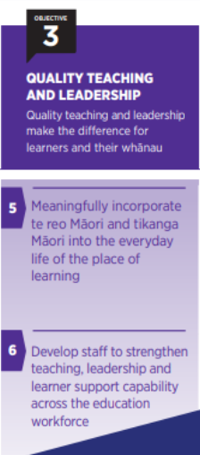
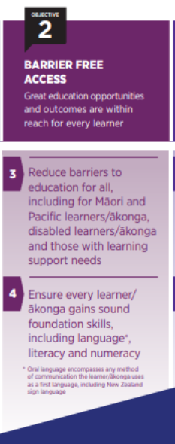
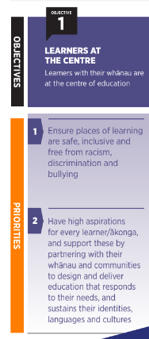

ANNUAL PLAN 2023
1. STUDENT ACHIEVEMENT / LOCALISED CURRICULUM DEVELOPMENT
a. MATHEMATICS CURRICULUM
Professional Development in Mathematics with Kirsty Sylvester - All Staff. Focus - Assessment.
2023 will be the third year of our in depth professional development with Kirsty Sylvester.
Term 1 - Coaching with each teacher and the Team Leader around assessment in Mathematics.
Analysis of standardised testing and development of next steps. (One Day)

Term 3 - Coaching with each teacher and the Team Leader around assessment in Mathematics.
Analysis of standardised testing and development of next steps. (One Day)
Teachers to analyse mathematics achievement data at the end of 2023 to confirm that the high standards achieved in 2022 have been maintained or improved further.

b. LITERACY CURRICULUM
Professional Development in Structured Literacy with Liz Kane - All staff
Phase 1 (February 2023 - March 2023)
Establishment Phase - Based on our 2022 end of year PGC self reflections we have established that there is a need amongst staff for professional development in Literacy teaching. We have also determined that following our analysis of standardised testing at the end of 2022, our literacy achievement is not as strong as our Maths achievement.
Whole staff to explore and confirm that as a staff we are willing to participate in some in depth professional development based on a structured literacy approach to the teaching of literacy.

Liz Kane to be employed as our resource person to provided guidance and support for this work.
Literacy Development Team to meet with Liz Kane to establish a clear ‘Why’.
Introductory staff meeting to be held in March.
Staff to then determine if what we know at that point is the direction the school needs to take.
A development plan to be documented by the end of Term 1.
This plan is to include: dates, format, costs, goals/outcomes, resource purchasing.

Phase 2 (April 2023 - September 2023)
Teacher Only Day - April 21st 2023 - Whole staff, including Support Staff
Whole staff to undertake professional development and to trial in class explicit teaching.
Staff Meeting: The Code
Date: May 23rd 3.15pm - 4.30pm
Middle and Senior Teams only

Catch up PD (Arlene Els (Teacher Rm 13, Sarah H Teacher (Rm 5), Caroline H, (Teacher Rm 12) Jude H) - Teacher Aide ESOL
Date: May 17th 1.30pm - 3pm

In School Modelling Day - Teachers to double up .
Reliever to release one of the teachers.
May 22nd Monday

Rachel & Caro to shadow Liz Kane

Term 3
Day - In class Coaching
Date: July 27 & July 31

2. FROM CULTURAL COMPETENCY TO RESPONSIVE PEDAGOGY

Palmerston North East Kahui Ako - Poutama Pounamu / Rangitane Iwi Development

Aims:
- Rangitane Engagement
- Develop and expand knowledge of Rangitane O'Manawatu
- Build relationships between school staff and Rangitane leaders
- Enable future collaboration between schools and Rangitane

- Responsive Pedagogy
- Develop common understandings of Responsive Pedagogy
- Develop school based Responsive Pedagogy Continuum
- Undertake a schoolwide stocktake and identify next steps
- Prepare for Responsive Pedagogy development cycles in 2024

ACTIONS
The school’s two Within Schools Teachers plus the Deputy Principal will complete the Blended Learning Programme through Waikato University throughout Term 1. (This work began in 2022)
Noho Marae - March 11th 2023
Principal’s Responsive Pedagogy Hui - February 16th 2023

Development of Rongohia te Hau professional development and survey process
Monday May 1st - Poutama Pounamu facilitators - Preparation Staff meeting No 1
Tuesday May 16th - Poutama Pounamu facilitators - Preparation Staff meeting No 2
Monday May 29th - Classroom Observations
June 2nd - Rangitane Symposium - All teachers across the Kahui Ako
School to complete Rongohia te Hau Surveys with students, teachers, parents. Analysis to take place and next steps to be determined in readiness for 2024

